Team #3

Functional Decomposition

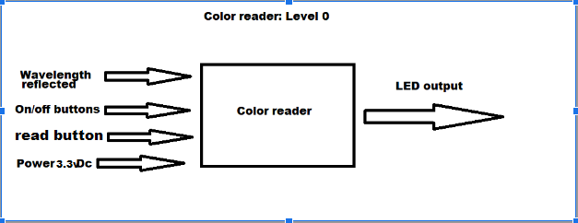

| Module | Color reader |
| --- | --- |
| Inputs | Color: wavelength  On/Off and read control: buttons  Power: 3.3v Dc |
| Outputs | Led displaying the color |
| Functionality | Reads the reflected wavelength then converts and displays the color on the LCD. User should be able to turn it on/off and when to take the a new reading |

Color reader: Level 1

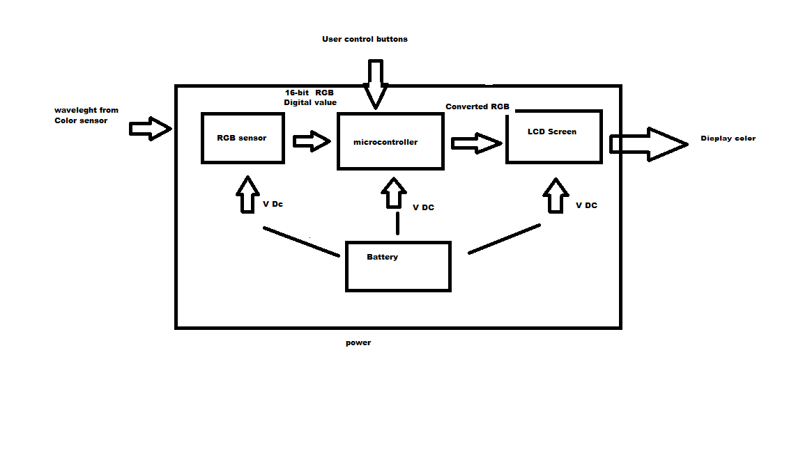

| *Module* | RGB sensor |
| --- | --- |
| *Inputs* | Wavelength reflected  Power: 0.5v to 3.8v |
| *Outputs* | RGB 16-bit Digital value |
| *Functionality* | Provides a digital value of RGB of incoming light |

| *Module* | *Battery* |
| --- | --- |
| *Inputs* | *Power 9V* |
| *Outputs* | *9V dc battery* |
| *Functionality* | *Provide power to turn on* |

| *Module* | *LCD screen* |
| --- | --- |
| *Inputs* | *Converted RGB digital*  *Power: 5v* |
| *Outputs* | *Readable information* |
| *Functionality* | *Displays to the user the color* |

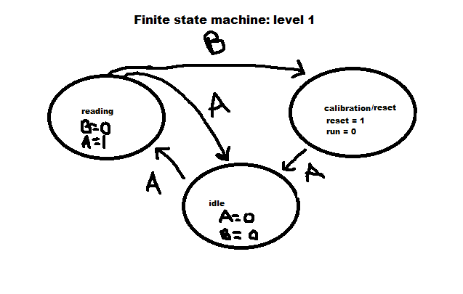

| *Module* | microcontroller |
| --- | --- |
| *Inputs* | Power: 2.7v to 5.5v  Clock: 0 to 8MHz  Color sensor |
| *Outputs* | Reset/read modes  LCD  Color sensor |
| *Functionality* | Changes the color sensor from reset and run modes |